**C:\Users\c.potter\AppData\Local\Microsoft\Windows\Temporary Internet Files\Content.IE5\IKUM6SW7\MCj02903600000[1].wmfHUBBLE: MORE THAN JUST**

**ANOTHER TELESCOPE!**

Since the earliest days of astronomy, since the time of Galileo, astronomers have shared a single goal — to see more, see farther, see deeper.

The Hubble Space Telescope's launch in 1990 sped humanity to one of its greatest advances in that journey. Hubble is a telescope that orbits Earth. Its position above the atmosphere, which distorts and blocks the light that reaches our planet, gives it a view of the universe that far surpasses that of ground-based telescopes. Hubble is one of NASA's most successful and long-lasting science missions. It has beamed hundreds of thousands of images back to Earth, shedding light on many of the great mysteries of astronomy. Its gaze has helped determine the age of the universe, the identity of quasars, and the existence of dark energy.

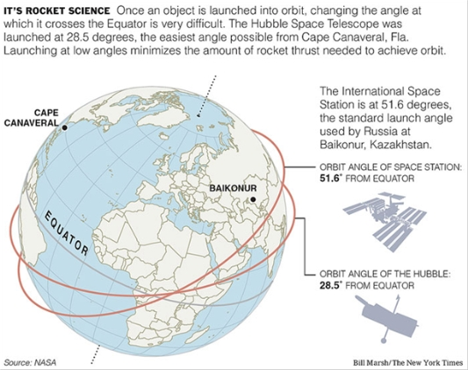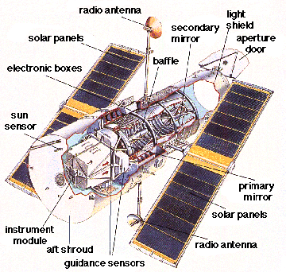

Hubble's discoveries have transformed the way scientists look at the universe. Its ability to show the universe in unprecedented detail has turned astronomical conjectures into concrete certainties. It has narrowed down the collection of theories about the universe even as it sparked new ones, clarifying the path for future astronomers.

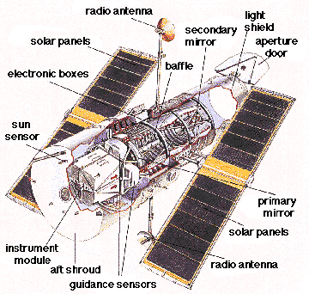

**Key Discoveries**

Among its many discoveries, Hubble has revealed the age of the universe to be about 13 to 14 billion years, much more accurate than the old range of anywhere from 10 to 20 billion years.

Hubble played a key role in the discovery of dark energy, a mysterious force that causes the expansion of the universe to accelerate.

Hubble has shown scientists galaxies in all stages of evolution, including toddler galaxies that were around when the universe was still young, helping them understand how galaxies form. It found protoplanetary disks, clumps of gas and dust around young stars that likely function as birthing grounds for new planets.

It discovered that gamma-ray bursts — strange, incredibly powerful explosions of energy — occur in far-distant galaxies when massive stars collapse.

These are only a handful of its many contributions to astronomy. The sheer amount of astronomy based on Hubble observations has also helped make it one of history's most important observatories. More than 6,000 scientific articles have been published based on Hubble data.

**Hubble Policies**

The policies that govern the telescope have contributed to its incredible productivity. The telescope is an instrument for the entire astronomical community — any astronomer in the world can submit a proposal and request time on the telescope. Teams of experts then select the observations to be performed. Once observations are completed, the astronomers have a year to pursue their work before the data is released to the entire scientific community.

Because everyone gets to see the information, the observations have given rise to a multitude of findings — many in areas that would not have been predicted by the telescope’s original proposals. Hubble's success with these policies has helped spread them throughout the astronomical community, and they are becoming common with other observatories.

**Facts About Hubble**

* Every 97 minutes, Hubble completes a spin around Earth, moving at the speed of about 8 km per second — fast enough to travel across Australia in about 8 minutes.
* The larger a telescope's mirror, the more light it can collect, and the better its vision. Hubble's primary mirror is 94.5 inches (2.4 m) in diameter. This mirror is small compared with those of current ground-based telescopes, which can be 400 inches (1,000 cm) and up, but Hubble's location beyond the atmosphere gives it remarkable clarity.
* At the time of its launch Hubble had cost around US$1.5 billion.
* The Hubble telescope is solar powered and it has two 25-foot solar panels to supply its energy needs
* The Hubble can't observe Mercury or the Sun; it is too close to them for it to be able to capture images due to the extreme brightness of the sun.
* Hubble sends 120 GB of science data every week. This is equivalent to about 1 Km of books on a shelf.